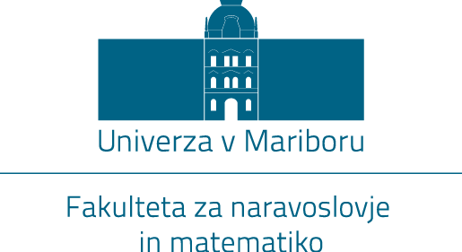

REGISTRATION OF ROOM ENTRY
Room: ___________________________
Date and time: ____________________________
Digital identity (name.surname@student.um.si): ________________________
Course: __________________________________________

Mark appropriately:
☐ with my signature i hereby confirm my attendance and that I am healthy. only healthy people, who do not show signs of illness, can enter the premises of the faculties of the University of Maribor, as otherwise they can endanger the health of other students and employees.

The University of Maribor collects the room entry data in line with the National Institute for Public Health guidelines in case of suspicion of infection or infection with corona virus (COVID-19). The data is processed in accordance with article 6 (1) (d) regulation (EU) 2016/679 of the European Parliament and Council, 27. April 2016 - protection of individuals with regard to the processing of personal data and on the free movement of such data and repealing the Directive 95/46/ES (General Data Protection Regulation). The data will be stored for 30 days at the individual faculty's student affairs office and destroyed after.
For more information on handling of data protection at the University of Maribor please visit: https://www.um.si/univerza/varstvo-osebnih-podatkov/Strani/default.aspx. You can also get information regarding handling of data protection at the University of Maribor data protection officer doc. dr. Miho Dvojmoča (dpo@um.si).

SIGNITURE:
________________________

